Boosting Bagging

Table of Contents
Boosting 1
How Boosting Works 1
Bagging vs. Boosting 2
Different Boosting Algorithms 2
Bagging (Bootstrap Aggregating) 3
Workflow 3
Why Bagging? 3
AdaBoost (Adaptive Boosting) 3
Steps in AdaBoost: 4
Gradient Boosting 4
Steps: 4
Basics of Linear Programming 6
Example Formula: 6
Applications: 6
Boosting 7
Bagging (Bootstrap Aggregating) 7
Gradient Boosting 7
Bagging vs. Boosting 8
Linear Programming 8
Example Summary 9
Boosting: 9
Bagging: 9
Linear Programming: 9

Boosting
Boosting is an ensemble learning technique that improves the performance of weak learners (models that perform slightly better than random guessing) by combining them into a strong learner. It works sequentially, where each model focuses on correcting the errors of its predecessor.

How Boosting Works
- Initialize weights: Start by assigning equal weight to all data points and use this weighted data to train the first model (Model 1).
- Update weights: For misclassified data points, increase their weights so that the next model (Model 2) pays more attention to them.
- Repeat: Continue training models sequentially, updating weights after each step, until a desired level of accuracy is achieved or the specified number of iterations is completed.
Key Concepts:
- Boosting focuses on reducing bias (systematic errors) and misclassified data points.
- Models are dependent, as each one is influenced by the errors of the previous model.
Formula Example for Updating Weights in AdaBoost:

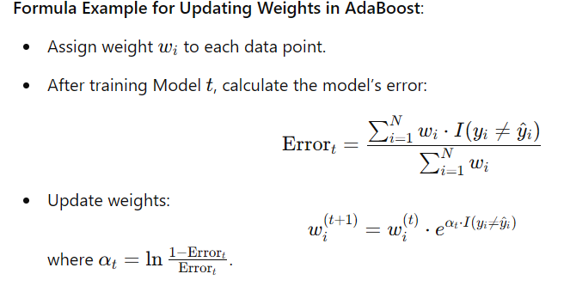

Bagging vs. Boosting
Aspect | Bagging | Boosting
Training | Parallel | Sequential
Sampling | Random sampling with replacement | Weighted sampling without replacement
Focus | Reduces variance | Reduces bias
Overfitting | Helps prevent overfitting | May slightly increase overfitting

Different Boosting Algorithms
- AdaBoost:
  - Combines many weak classifiers (e.g., decision stumps) by weighting them.
  - Focuses on data points misclassified by previous classifiers.
- Gradient Boosting:
  - Optimizes a loss function by combining weak learners.
  - Typically uses decision trees as weak learners.
  - Works for regression and classification tasks.
Steps:
  - Minimize the loss function L(y,f(x))L(y, f(x))L(y,f(x)).
  - Fit a weak learner to the negative gradient of the loss function.
- XGBoost:
  - An efficient and scalable implementation of gradient boosting.
  - Optimized for speed and performance using techniques like tree pruning and regularization.
- CatBoost:
  - A gradient boosting algorithm specifically designed for categorical data.
  - Handles categorical features without extensive preprocessing.

Bagging (Bootstrap Aggregating)
Bagging is another ensemble technique that reduces the variance of high-variance models (e.g., decision trees). It involves building multiple models in parallel on different random subsets of the data (with replacement) and averaging their predictions.

Workflow
- Bootstrapping: Create random samples from the dataset using replacement.
- Model training: Train the same or different models on each sample.
- Combine results: Aggregate predictions (e.g., majority voting for classification or averaging for regression).

Why Bagging?
- Reduces overfitting in high-variance models.
- Handles both classification and regression problems.

Example Formula for Combining Predictions:

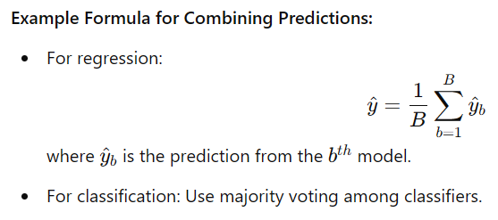

AdaBoost (Adaptive Boosting)
A specific boosting algorithm that combines weak classifiers to create a strong classifier.

Steps in AdaBoost:

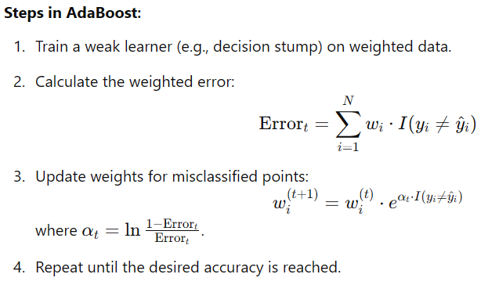

Gradient Boosting
A boosting algorithm focused on minimizing a loss function through additive models.

Steps:

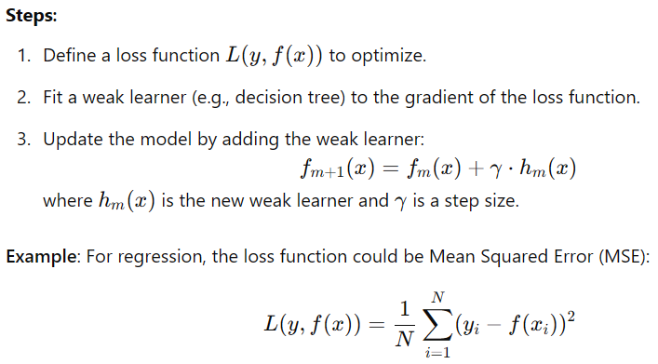

Basics of Linear Programming
Linear programming is a mathematical technique to find the optimal value of a linear objective function, subject to linear constraints.

Example Formula:
Maximize or minimize:
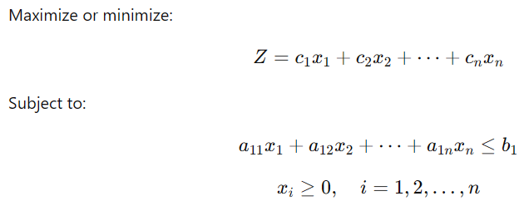

Applications:
- Machine learning: Neural network training (e.g., minimizing loss functions).
- Operations research: Optimizing resource allocation.

Boosting
- Who: Data scientists and machine learning practitioners use boosting when they need to improve the performance of weak models.
- What: Boosting is an ensemble technique that combines weak learners to create a strong model by correcting the errors of each previous learner.
- When: Use boosting when you want to reduce bias and improve the predictive power of models, especially for structured data problems like classification and regression.
- Where: Commonly applied in scenarios with tabular data, like finance (fraud detection), healthcare (disease prediction), and marketing (customer churn prediction).
- Why: Boosting ensures better accuracy by focusing on the most difficult-to-predict data points, addressing bias in the data.
- How: Sequentially train models, updating weights for misclassified data points after each iteration.

Bagging (Bootstrap Aggregating)
- Who: Data scientists use bagging when dealing with high-variance models like decision trees.
- What: Bagging is an ensemble learning technique that builds multiple models in parallel on different bootstrap samples of the data and combines their predictions.
- When: Use bagging when overfitting is a concern, or the model has high variance (e.g., decision trees).
- Where: Commonly used in decision tree ensembles like Random Forests for both classification and regression problems.
- Why: Bagging reduces the variance of predictions by averaging results from multiple models, leading to more stable and accurate predictions.
- How: Generate bootstrap samples, train models independently on these samples, and aggregate their outputs (e.g., majority vote for classification, mean for regression).

Gradient Boosting
- Who: Data scientists and ML engineers use gradient boosting for optimizing regression and classification models.
- What: Gradient Boosting is a boosting algorithm that minimizes a loss function through iterative updates.
- When: Use gradient boosting when you need state-of-the-art performance for structured data.
- Where: Applications include finance (credit scoring), healthcare (risk prediction), and e-commerce (recommendation systems).
- Why: Gradient boosting improves model performance by minimizing the loss function (e.g., MSE for regression or log-loss for classification).
- How: Fit weak learners to the negative gradient of the loss function, iteratively building a strong model.

Bagging vs. Boosting
- Who: Both bagging and boosting are used by data scientists for improving model accuracy and stability.
- What:
  - Bagging: Combines multiple models trained on random samples.
  - Boosting: Sequentially combines models, focusing on correcting errors.
- When:
  - Bagging: Use when overfitting is a problem (reduces variance).
  - Boosting: Use when the model needs to improve accuracy and reduce bias.
- Where:
  - Bagging: Random Forests and decision trees.
  - Boosting: Gradient Boosting, AdaBoost, and XGBoost.
- Why:
  - Bagging reduces overfitting by averaging predictions.
  - Boosting improves predictions by focusing on misclassified data.
- How:
  - Bagging: Train models in parallel on bootstrap samples.
  - Boosting: Train models sequentially, adjusting weights iteratively.

Linear Programming
- Who: Operations researchers, data scientists, and ML engineers.
- What: Linear programming is a mathematical optimization technique to maximize or minimize a linear objective function subject to linear constraints.
- When: Use linear programming for resource allocation, scheduling, and optimization problems.
- Where: Applications include logistics (route optimization), manufacturing (resource allocation), and ML (training neural networks).
- Why: It provides an efficient way to solve real-world problems with constraints, optimizing resources or costs.
- How:
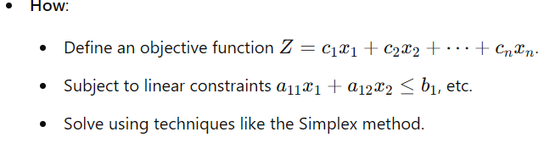

Example Summary

Boosting:
- Focus: Correct misclassified data sequentially.
- Example Algorithm: AdaBoost, Gradient Boosting.

Bagging:
- Focus: Reduce variance by combining predictions from models trained in parallel.
- Example Algorithm: Random Forest.

Linear Programming:
- Focus: Optimize a specific objective under constraints.
- Example Use: Minimize cost or maximize profit.

What is Stacking?
Stacking (short for Stacked Generalization) is an ensemble learning technique where multiple models (base models) are trained to make predictions, and their outputs are combined using a higher-level meta-model to improve the overall prediction accuracy.

How Stacking Works
- Base Models (Level 0):
  - Train multiple diverse models (e.g., decision trees, logistic regression, neural networks) on the same dataset.
  - Each model makes predictions on the dataset.
  - These predictions are the "inputs" for the meta-model.
- Meta-Model (Level 1):
  - A separate model (e.g., logistic regression, gradient boosting) is trained on the predictions of the base models.
  - It learns to combine the strengths of the base models to make better predictions.

Steps in Stacking
- Split the Data:
  - Split the training dataset into two parts:
    - One part is used to train the base models.
    - The other part is used to train the meta-model.
- Train Base Models:
  - Train multiple base models (e.g., Decision Tree, Random Forest, SVM) on the first part of the training data.
  - Use these models to make predictions on the second part of the training data.
- Train Meta-Model:
  - Use the predictions of the base models as input features for the meta-model.
  - The target remains the same as the original target variable.
- Combine Predictions:
  - When making predictions on new data, base models first make predictions.
  - These predictions are passed to the meta-model, which makes the final prediction.

Example
- Dataset:
  - Input features: X=[x1,x2,...,xn]
  - Target variable: y
- Base Models (Level 0):
  - Train a Decision Tree, SVM, and Random Forest on the data.
  - Output predictions: ydt,ysvm,yrf.
- Meta-Model (Level 1):
  - Train a Logistic Regression model on [ydt,ysvm,yrf] as input features.
- Final Prediction:
  - Combine predictions of base models using the meta-model.

Advantages of Stacking
- Combines the strengths of multiple models to improve prediction performance.
- Can handle diverse base models (linear and non-linear models).

Disadvantages of Stacking
- Computationally expensive compared to simpler ensemble techniques like bagging or boosting.
- Risk of overfitting if the meta-model is too complex.

Use Cases of Stacking
- Competition-winning solutions in machine learning competitions like Kaggle.
- Scenarios where you want to combine multiple types of models to leverage their diverse strengths.

1. Who uses Stacking?
- Data scientists and machine learning practitioners who want to improve model performance by combining diverse models.
- Commonly used in competitions like Kaggle or when high prediction accuracy is required.

2. What is Stacking?
- Stacking is an ensemble learning technique where multiple models (base models) are trained, and their predictions are combined using a meta-model to produce a final output.
- It combines the strengths of multiple algorithms to create a more accurate and robust model.

3. When is Stacking used?
- When multiple models (base learners) individually perform well but could be improved by combining their predictions.
- In scenarios where leveraging the diversity of models can reduce bias and variance.
- Often used in machine learning competitions or in high-stakes predictions like financial modeling or medical diagnostics.

4. Where is Stacking applied?
- Machine Learning Competitions: For achieving state-of-the-art accuracy.
- Industries:
  - Finance: Credit risk analysis.
  - Healthcare: Disease prediction.
  - E-commerce: Customer segmentation and recommendation systems.

5. Why use Stacking?
- To combine the strengths of different models:
  - A linear model might handle simpler relationships well.
  - A non-linear model might capture complex interactions.
  - Combining both helps achieve better performance.
- To improve accuracy and reduce generalization error.

6. How does Stacking work?
- Train Base Models (Level 0):
  - Train multiple diverse models (e.g., Decision Trees, Random Forest, Logistic Regression) on the training data.
  - Each model makes predictions.
- Create Meta-Model (Level 1):
  - Collect predictions from base models as input features.
  - Train a meta-model (e.g., Linear Regression, Gradient Boosting) on these predictions.
- Make Final Prediction:
  - Use the trained base models to predict for new data.
  - Pass these predictions to the meta-model for the final output.

Example Workflow
Imagine a dataset for predicting whether a loan will be approved:
- Base Models (Level 0):
  - Model 1: Logistic Regression
  - Model 2: Random Forest
  - Model 3: Support Vector Machine (SVM)
- Meta-Model (Level 1):
  - Gradient Boosting trained on the outputs of the three base models.
- Final Output:
  - The meta-model combines the predictions of the base models to provide the final prediction (approved or not).

